Video is http://www.heidelbergengineering.com/hrt-retina/
The Spectralis combines OCT and confocal laser angiography
Goldberg, L. Ophthalmology Management, August 2007.
Request Clinical Paper

HRT Retina Module

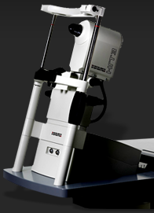
Front Line Evaluation of Macular Health
- Simple, early detection of subtle edema
- Retinal thickness mapping in 3-D
- Precise detection of change with TruTrack™ image alignment
- No interpolated data, less chance of missing pathology
- “Show and tell” for patient education
- Modular platform to add more capabilities later
- Network ready

SPECTRALIS® OCT

Spectral-Domain with Dual Beam Eye Tracking
- Dual-beam simultaneous imaging
- TruTrack™ eye tracking
- 40,000 A-scans per second
- Heidelberg Noise Reduction™
- Upgradeable
- Three different models
- Network ready

Retinal Edema Index
The Edema Index is a fast, easy method of detecting suspicious retinal areas that may not be readily apparent to the clinician even under careful contact lens examination. The HRT is designed to image retinal changes caused by minor accumulations of fluid. These changes often do not meet the definition of clinically significant macular edema, but may signal future problems. This information can be used to determine if patients should be followed more frequently. Edema Index Images
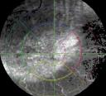 | 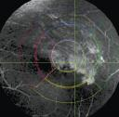 | 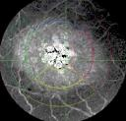 | 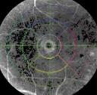
Age-related Macular Degeneration (AMD) | Diabetic Macular Degeneration (DME) | Cystoid Macular Edema (CME) | Macular Hole

Retinal Thickness
The retinal thickness measurements of the HRT Retina Module create a complete map of the scanned area without interpolating data. Compared to the Edema Index, Retinal Thickness maps may be more useful for tracking disease changes as therapy continues. The 3-D maps are helpful for showing and explaining retinal abnormalities to the patient. Retina Thickness 3-D Map Images
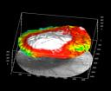 | 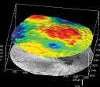 | 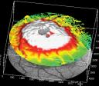 | 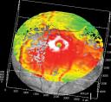
Age-related Macular Degeneration (AMD) | Diabetic Macular Degeneration (DME) | Cystoid Macular Edema (CME) | Macular Hole

Reflectance Map
The reflectance image is an additional tool on the HRT which helps to reveal retinal abnormalities. The reflectance image captures differences in the surface appearance of the retina and enables interpretation of both the Edema Index and the Retinal Thickness maps. Reflectance Map Images
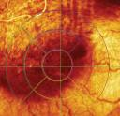 | 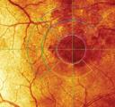 | 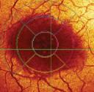 | 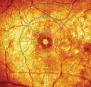
Age-related Macular Degeneration (AMD) | Diabetic Macular Degeneration (DME) | Cystoid Macular Edema (CME) | Macular Hole
Product Configurations 3D képek
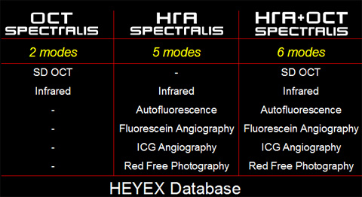
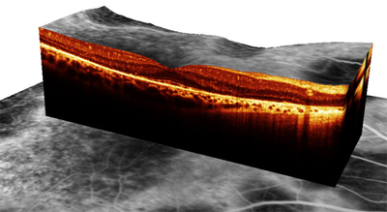
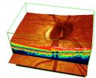

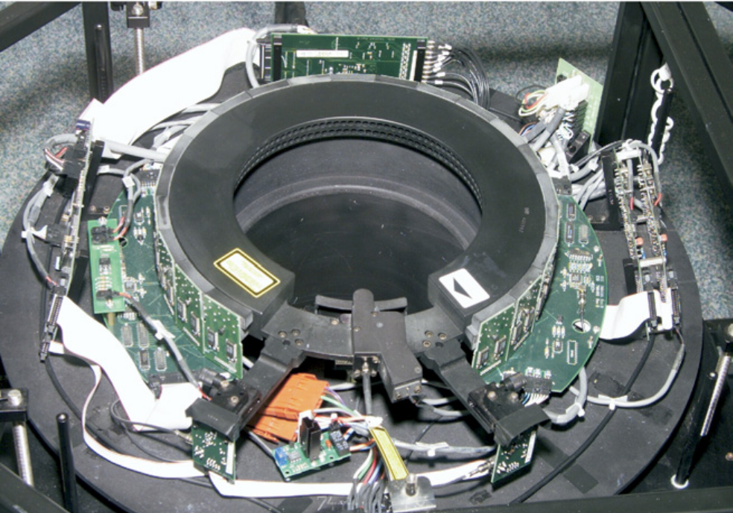
Gantry of the Computed Tomography Laser Mammography system using a third-generation computed tomography design. There is an array of 84 collimated photodiodes and a nearinfrared laser operating at 808 nm.

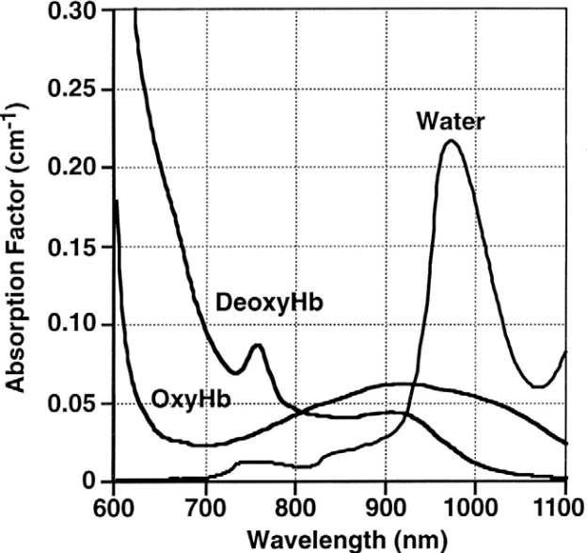
Medical optical spectral window demonstrated by the absorption spectra of the major chromophores in skin (20,21). The absorption factor is equivalent to the optical absorption coefficient, _a. OxyHb, oxyhemoglobin; DeoxyHb, deoxyhemoglobin.
(From Chance (21), with permission).

Computerised Tomography Laser Mammography

http://joneseyecenters.com/index.cfm/technology/heidelbergretina
http://www.heidelbergengineering.com

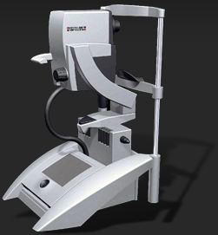
SPECTRALIS® OCT

Spectral-Domain with Dual Beam Eye Tracking
- Dual-beam simultaneous imaging
- TruTrack™ eye tracking
- 40,000 A-scans per second
- Heidelberg Noise Reduction™
- Upgradeable
- Three different models
- Network ready

Image Library
Click on the following thumbnails of the images to display the full size image:
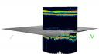 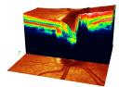 
Vitreal Peripapillary Peripapillary Serpiginous
Artifact IR 15º Atrophy IR 15º Atrophy IR 15º Choroidopathy 20º

 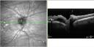 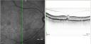 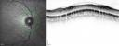
Peripapillary Peripapillary VMT IR 30º Normal IR 30º
Atrophy IR 15 º Lesion IR 30º ……….
Spectralis® OCT

Spectral-Domain with Dual Beam Eye Tracking
- Dual-beam simultaneous imaging
- TruTrack™ eye tracking
- 40,000 A-scans per second
- Heidelberg Noise Reduction™
- Upgradeable
- Three different models
- Network ready

http://joneseyecenters.com/index.cfm/technology/alconseries2000legacy
http://joneseyecenters.com/index.cfm/procedures/cataractsurgery

